# Lab- 6 nmap Scripts

1. Scripts for NMAP tool can be used for different purposes like extracting more information, brute forcing, password guessing et cetera.

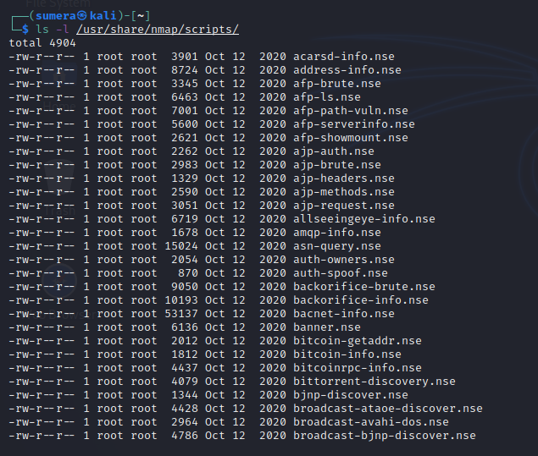

1. Specific scripts can also be viewed.

